# CS4112/CS54111 INTRODUCTION TO DATA SCIENCE

# The Exercise.1: Use ggplot2 histogram to show the price distribution(frequencies). From the histogram what you can tell about the price range most people prefer to buy?



From the histogram we can tell that people prefer to buy the diamonds with the price < $1000,

particularly, the range between $500 ~ $1000

# Exercise.2: Answer the following questions by adding R statements that prints the answers for these questions:

#Q1. The mean value of the prices is $3932.8 :

price.mean<- mean(diamonds$price,trim = 0 ,na.rm= TRUE)

print(price.mean)

#Q2. The numbers of diamonds with price<= $500 is 1749 :

sum(diamonds$price <= 500)

#Q3. The numbers of diamonds with price>= $10000 is 5223 :

sum(diamonds$price >= 10000)

# Exercise.3: Plot a histogram of the prices distribution for prices up to $2500. Design your histogram to show values for each $500 increment. Can you tell now which bin has the highest value?



From the graph we could tell that most of the diamonds prices are around $500 ~ $1200 and that is also most people prefer to buy.

# Exercise.4: Use the scatter graph to show the relation between the carat and price



The information we could tell from the graph is that the carat increases, the price of diamonds will also increase.

Moreover, It’s very useful to plot transformations of your variable. For example, it’s easier to see the precise relationship between carat and price if we log transform them:



From the log scatter graph, we could clearly see that the price of diamonds will increase with increasing carat, they have positive changing relation to each other.

# Exercise.5: Use scatter graph to show the relation between the carat and the volume of the diamond (the multiplication of the three dimensions x*y*z)

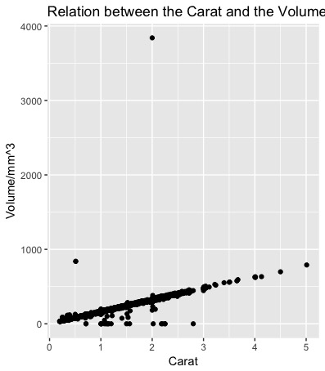

Then we could see that volume over 1000 mm3 has minority data recorded, so we would better to shrink the range of Volume (the y axis) to make the visualization better:

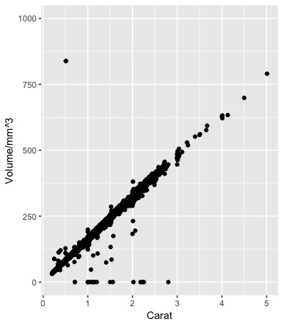

# Exercise.6: Use scatter graph to show the distribution of prices vs carat according to the color type of the diamond.

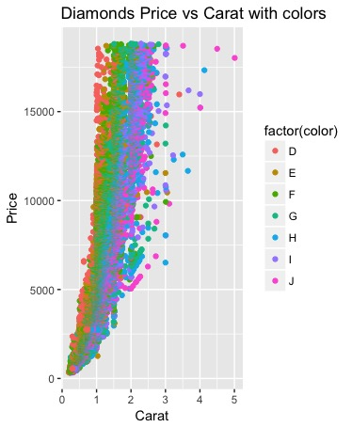

According to the standard of measure how good the color of diamond, we could tell the information from the scatter graph:

Color D(best) basically distributes less than 1 carat and the more the carat one diamond is, the worse the color is.

And you could find all levels of color from each price level.

# Exercise.7: Use scatter graph to show the distribution of prices vs carat according to the cut type of the diamond.

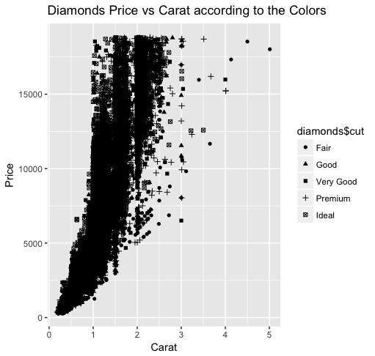

Sometime we could not tell the exact information from the graph like this, then we should use the xlim(…) / ylim(…) to limit the range of variables.

We could see that the higher the price is the better quality the diamond has.

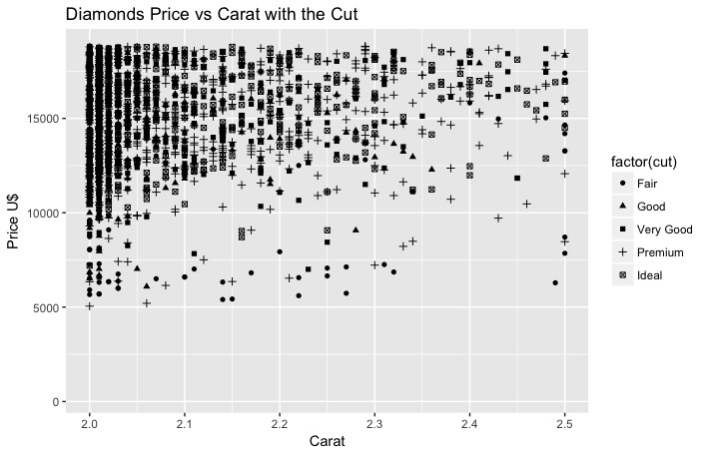

# Exercise.8: Using the scatter graph f price vs carat, plot a smooth curve that can fit the trend of the data.

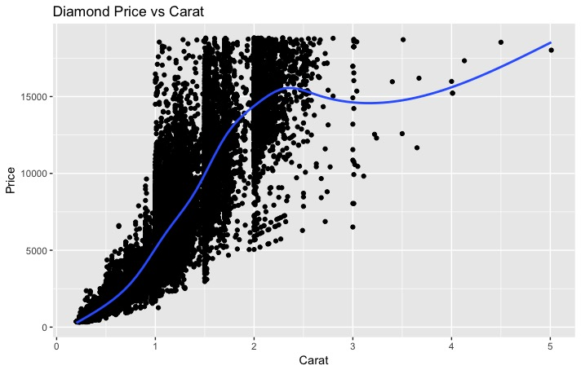

The smooth curve that showing the trend of the data:

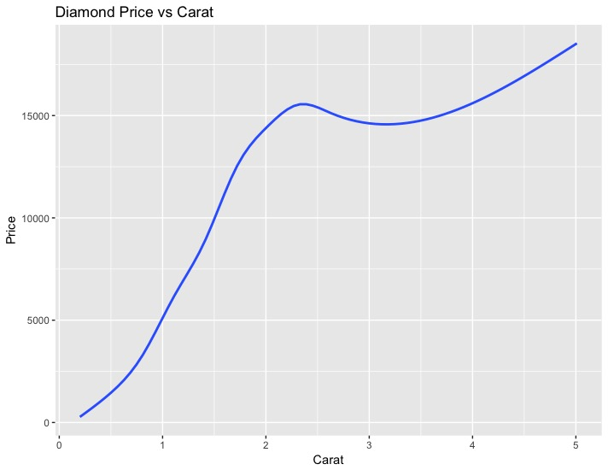

The log transform trend graph:

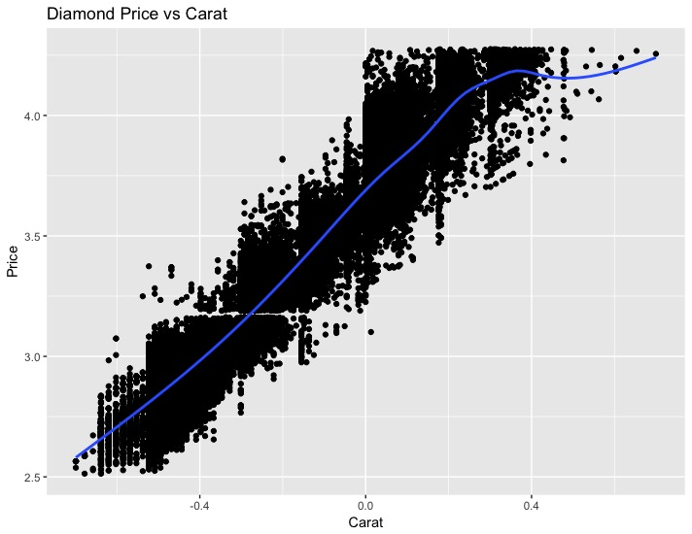

The trend curve:

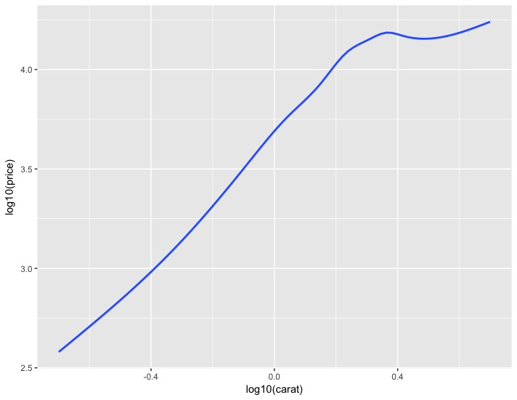

# Exercise.9: Using the scatter graph of price vs carat with respect to the diamond color and find a smooth line that fits such scattered data.

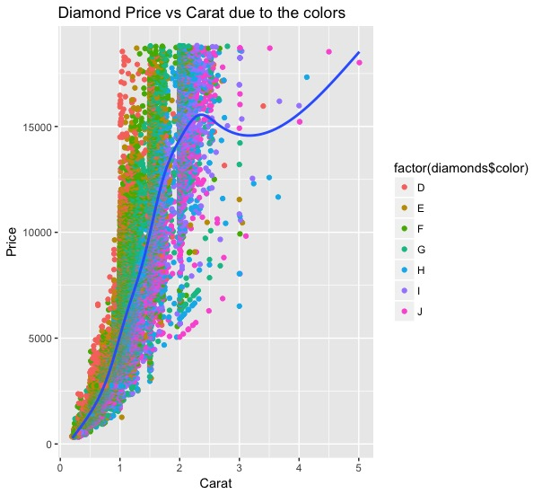

# Exercise.10: Make a different observation of your own using the diamond data. You can use data manipulation or visualization or both.

As I already done before, I made some code manipulation to make either histogram graph or scatter graph has better visualization.

1. Like using ylim(0,1000) and xlim(2,2.5) to remove some minority data from the outer range which may not be very helpful and useful when we analyze the data.
2. Using the x= log10(variable), and y=log10(variable) method is easier to see the relationship between i.e. carat and price if we log transform them.